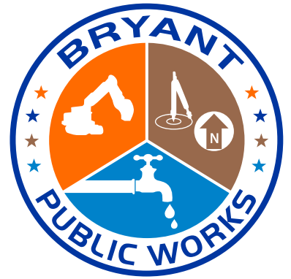
City of Bryant
1017 SW 2nd Street
Bryant, AR 72022
(501) 943-0469
www.cityofbryant.org

INVITATION AND BID SPECIFICATIONS FOR PLASTIC PIPE AND MATERIAL BIDS
2022 calendar year

The City of Bryant is accepting bids on Plastic Pipe and Materials for the calendar year of 2022.

All bids must be received by the City of Bryant located at 1017 SW 2nd Street, Bryant, AR 72022, Attn: Public Works C/O: Christina no later than 8:00 a.m., Monday, December 20, 2021 at 8:00AM.

BID OPENING DATE: Tuesday, December 21, 2021 @ 9AM
LOCATION: PUBLIC WORKS CONFERENCE ROOM
1019 SW 2ND STREET, BLDG #3
BRYANT, AR 72022

The City reserves the right to reject any or all bids, to waive irregularities and/or informalities of any bid, and to make an award in any manner consistent with the law, or deemed in the best interest of the City.

Evaluation of the bids will include compliance with bid specifications and pricing. Please note that price alone may not be the sole consideration in awarding this bid.

Bid envelopes must be sealed and clearly marked with the following:

“Bid No. 2022-2 Plastic Pipe and Material”

City of Bryant
Annual Plastic Pipe and Material Bid
Bid No. 2022-2
Bid Opening Date: Tuesday, December 21, 2021
Public Works Conference Room @ 9:00 a.m.
1019 SW 2nd Street, Bldg #3 Bryant, AR 72022
____________________________________________________________________________________________
ASTM HP STORM

1. 12” HDPE per ft. $_____________ $___________
2. 15” HDPE per ft. $_____________ $___________

3. 18” HDPE per ft. $_____________ $___________

4. 24” HDPE per ft. $_____________ $___________

5. 30” HDPE per ft. $_____________ $___________
6. 36” HDPE per ft. $_____________ $___________

7. 42” HDPE per ft. $_____________ $___________
8. 48” HDPE per ft. $_____________ $___________
9. 60” HDPE per ft. $_____________ $___________

10. 1” Irrigation
Meter Setter each $_____________ $___________

11. 1x5/8 Setter each $_____________ $___________

12. 3/4 x 5/8 Setter
W/check valve each $_____________ $___________

13. 3 x 6 CTS
Full Circle each $_____________ $___________

14. 3/4 x 3 CTS
Full Circle Clamp each $_____________ $___________

15. 1 x 100 Municpex
Plastic Pipe per ft. $_____________ $___________

16. 3/4 x 100 Municpex
Plastic Pipe per ft. $_____________ $___________

17. 2” ARI Valves each $_____________ $___________

18. 8” HDPE Fusion Pipe per ft. $_____________ $___________

19. 10” HDPE Fusion Pipe per ft. $_____________ $___________

20. 12” HDPE Fusion Pipe per ft. $_____________ $___________

21. 8” Ductile Iron 250 Class per ft. $_____________ $___________

Pricing should include delivery.

Unsigned bids will be rejected.

Authorized Agent bidding on this project:

_________________________________________________
Company Name

_________________________________________________
Company Representative Name

_________________________________________________
Representative’s Signature

_________________________________________________
Date

_________________________________________________
Address

_________________________________________________
Email Address

_________________________________________________
Telephone Number / Fax Number

